STA 135 - Project 1
Spring 2026

Name: Ian Dang 919932971, Weitao Chen 920926688

Instructor: Maxime Pouokam

Date: 04/28/2026



Introduction:
This report analyzes the Birthweight dataset, which contains 42 observations of newborn babies and their parents. The main physical variables are birthweight, length, and head circumference, while the parent variables include age, education, height, and smoking behavior. Birthweight ranges from 1.92 kg to 4.57 kg, with a mean of 3.31 kg and a standard deviation of 0.6 kg. Gestation ranges from 33 to 45 weeks, with an average of 39.19 weeks. About 52.4% of mothers smoke, and 14.3% of babies are classified as low birthweight. This analysis uses summary plots, covariance, and table rather than formal model fittings, following the project instruction to avoid model fitting.

1. Summary Plots Interpretation:
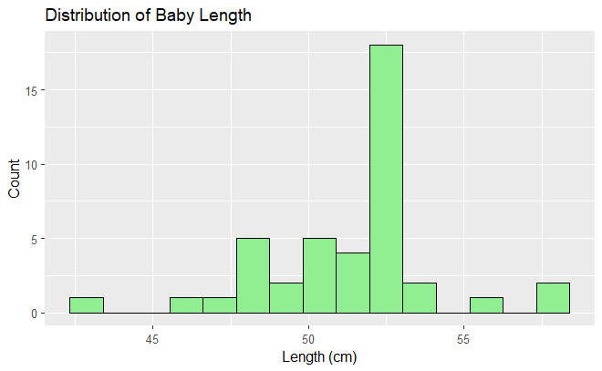
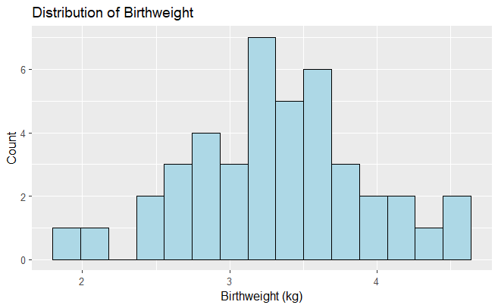
$Figure 1: Birthweight Histogram$ $Figure 2:Baby Length Histogram$
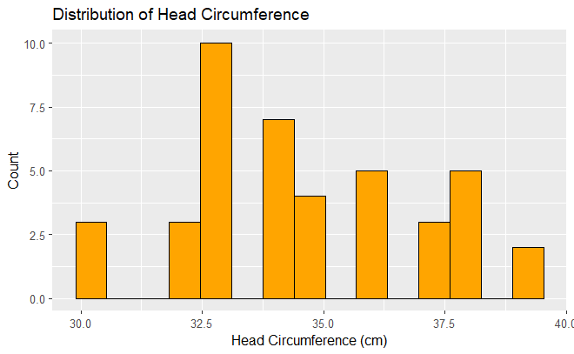
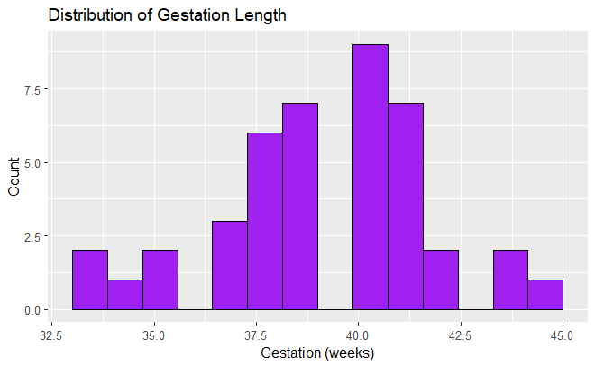
$Figure 3: Head Circumference Histogram$ $Figure 4: Gestation Length Histogram$

This distribution of birthweight is unimodal and centered around 3.31 kg, with values ranging from 1.92 to 4.57 kg, resulting in a total spread of 2.65 kg. The majority of observations fall within the interval from around 2.8 to 3.8 kg, indicating moderate dispersion around the mean. The histogram suggests slight negative skewness due to the presence of several low birthweight observations below 2.5 kg. In comparison, infant length ranges from 43 to 58 cm, with a mean of 51.33 cm, and appears approximately symmetrical with a slight right tail driven by a few larger values above 55 cm. Head circumference varies from 30 to 39 cm, with an average of 34.60 cm, and exhibits relatively low variability, indicating that measurements are tightly clustered around the mean. Gestation age spans from 33 to 45 weeks, with most observations concentrated between 38 to 41 weeks, consistent with full term births, and a slight left tail reflecting preterm deliveries,
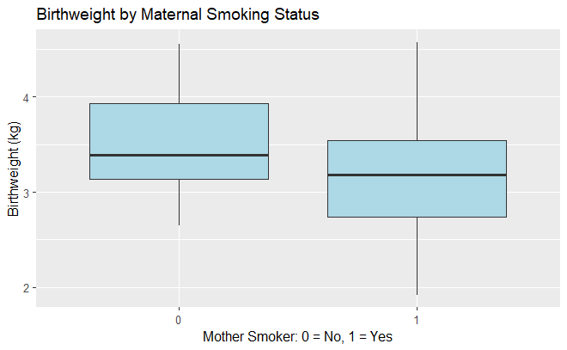

$Figure 5: Boxplot of Birthweight by Maternal Smoking Status$

The comparison of birthweight distributions by maternal smoking shows a clear downward shift for infants born to the smoking mothers. Babies born to nonsmoking mothers have a higher central tendency, with a mean birthweight of approximately 3.31 kg, while the distribution for smoking mothers is centered at a lower value. The interquartile for smokers is also shifted downward, and there is a greater concentration of observations in the lower tail, especially below 2.8 kg. This pattern indicates a negative association between maternal smoking and birthweight.

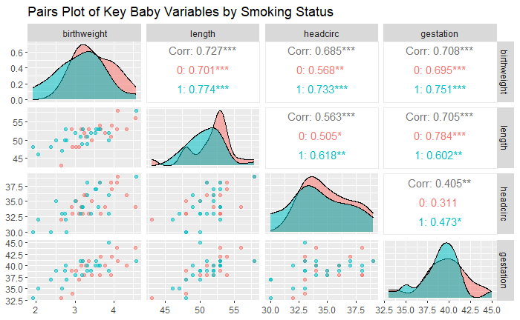

$Figure 6:Pairwise Relationships of Neonatal Physical Variables by Smoking Status$

The pairwise relationships among the variables indicate strong positive linear associations between birthweight and other anthropometric measures. The correlation between birthweight and length is approximately 0.727, while the correlation with head circumference is about 0.685, and with gestational age is approximately 0.708. These values imply that roughly 47% to 52% of the variation in birthweight can be explained by each predictor individually through a linear relationship. Additionally, length and gestation are strongly correlated at approximately 0.705, indicating that longer gestational periods are associated with increased overall fetal growth. The relationship between head circumference and gestation is weaker, with a correlation of about 0.405, suggesting that head growth is less sensitive to gestational duration than overall body size. When examining these relationships by maternal smoking status, the correlations remain positive in both groups but are generally stronger among non smokers, indicating more consistent growth patterns is not present and suggests smoking introduces additional variability.

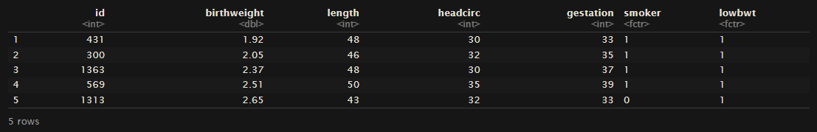
$Figure 7:Lowest Birthweight Observations and Associated Physical Characteristics$
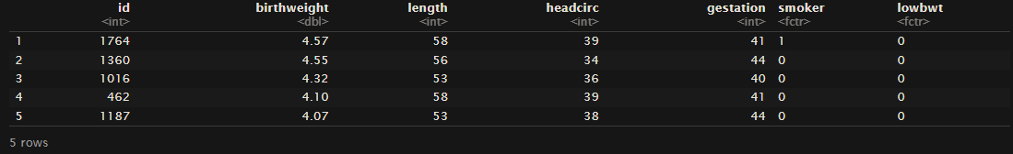
$Figure 8: Highest Birthweight Observations and Associated Physical Characteristics$

The lowest birthweight observation, corresponds to IDS 431, 300, 1363, 569, and 1313, ranging from 1.92 to 2.65 kg and are associated with shorter gestational periods between 33 to 37 weeks, reduced lengths between 43 cm and 50 cm, and smaller head circumference between 30 and 35 cm. These characteristics are consistent with preterm birth and restricted fetal growth. In contrast, the highest birthweight observations, including IDs 1764, 1360, 1016, 462, and 1187, range from 4.07 to 4.57 kg and are associated with longer gestational periods between 40 to 44 weeks, greater lengths between 53 cm and 58 cm, and larger head circumferences between 36 to 39 cm. These observations align with expected patterns of increased fetal growth at longer gestational durations and do not appear to be anomalous given their consistency across multiple physical measurements.

2. Covariance and Correlation:
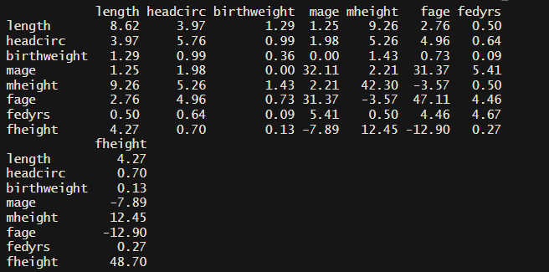
$Figure 9:Covariance Matrix of Neonatal Physical Variables and Parental Demographic Factors$

The cross covariance structure between neonatal physical characteristics and parental demographic variables indicate that maternal height is a more dominant predictor among the variables considered. In particular, the covariance between maternal height and neonatal length is 9.26, which is substantially larger than all other cross variances, indicating a strong positive linear association in absolute scale. Maternal height also exhibits positive covariance with head circumference (5.26) and birthweight (1.43), suggesting that increases in maternal height are consistently associated with increases across multiple dimensions of neonatal size. The magnitude of these covariances, especially for length and head circumference, reflects both the strength of the relationship and the scale of the variables, reinforcing the importance of maternal biological characteristics in explaining variation in infant physical development.

In contrast, parental height shows weaker associations with neonatal outcomes. Although the covariance between father’s height and neonatal is 4.27, this value is notably smaller than the corresponding maternal relationship, and the covariances with head circumference (0.70) and birthweight (0.13) are relatively modest. This indicates that while paternal height may contribute to variation in neonatal size, its influence is less pronounced and less consistent across dimensions compared to maternal height. The comparatively lower magnitude suggests that the maternal biological factors may play a more direct role during gestation.
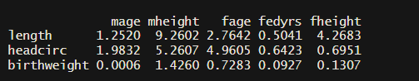

$Figure 10:Cross Covariance Between Neonatal Physical Measures and Parental Demographic Variables$

Maternal age and parental education shows minimal linear association with neonatal physical characteristics. The covariance between maternal age and birthweight is approximately 0.0006, showing no measurable linear relationship. Similarly, parental education (fedyrs) shows very small covariance values across all neonatal variables such as birthweight and length. This reveals that variation in education levels does not translate into observation differences in neonatal physical size within this sample.
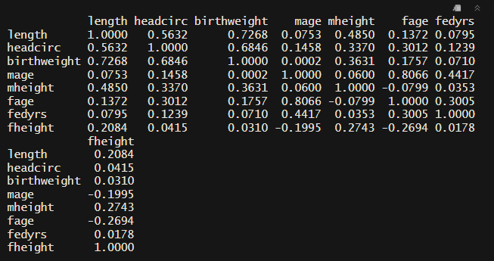

$Figure 11:Correlation Matrix of Neonatal Physical and Parental Demographic Variables$

The correlation matrix provides a scale-invariant confirmation of these findings. Maternal height exhibits moderate positive correlations with neonatal length (r = 0.485), head circumference (r = 0.337), and birthweight (r = 0.363), indicating consistent but not perfectly linear relationships after standardizing for variability. In contrast, correlations involving maternal age and paternal education remain weak, generally below 0.10, reinforcing the lack of meaningful linear association. Paternal height shows weaker correlations overall ( r = 0.208 with length and r = 0.031 with birthweight), further supporting the conclusion that maternal height is the primary demographic factor associated with neonatal physical outcomes.

3. Predictive Modeling:
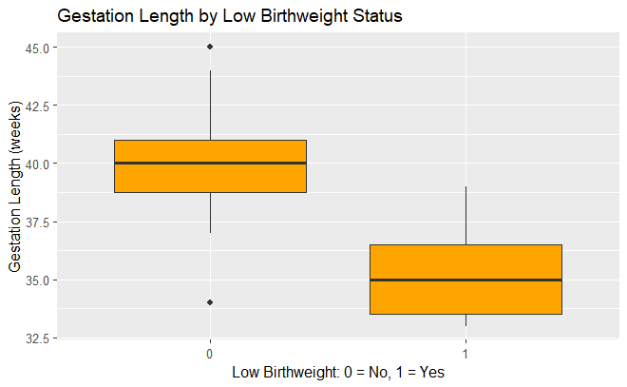

$Figure 12:Distribution of Gestational Length by Low Birthweight Status$

The boxplot of gestation length by low birthweight status shows a clear separation between groups, with low birthweight infants concentrated between approximately 33 and 36 weeks and non-low birthweight infants centered around 39 to 41 weeks. This difference in central tendency indicates a strong negative association between gestational length and the probability of low birthweight, with shorter gestation substantially increasing risk.
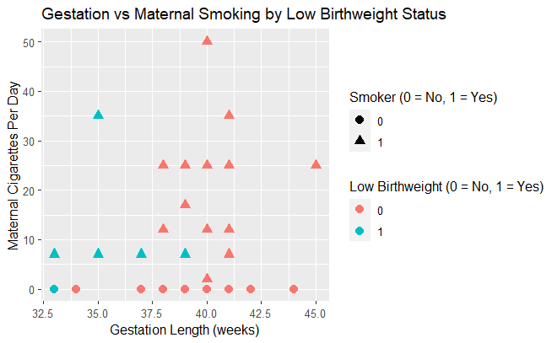
$Figure 13:Gestation Length and Maternal Smoking Intensity by Low Birthweight Status$

The scatterplot of gestation versus maternal cigarette consumption, stratified by low birthweight status, shows that low birthweight cases tend to occur at both shorter gestational lengths and higher levels of cigarette use. In contrast, non low birthweight observations are concentrated at longer gestations and lower smoking levels. This pattern suggests that both reduced gestation and increased smoking intensity contribute jointly to low birthweight outcomes.
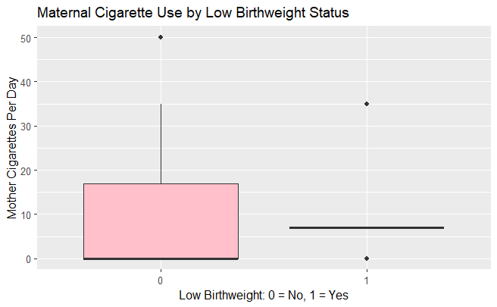

$Figure 14:Maternal Cigarette Consumption by Low Birthweight Status$

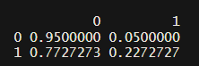
The distribution of maternal cigarette consumption supports a dose-response pattern. Low birthweight cases are more frequently associated with higher levels of cigarette use, including observations exceeding 25 cigarettes per day, whereas non-low birthweight observations are concentrated near zero consumption. This separation suggests that increased smoking intensity is associated with a higher probability of low birthweight.
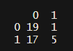

$Figure 15:Maternal Cigarette Consumption by Low Birthweight Status$

The contingency table shows a clear difference in the proportion of low birthweight outcomes by maternal smoking status. Among non-smoking mothers, approximately 5 percent of babies are classified as low birthweight, whereas this proportion increases to about 22.7 percent among smoking mothers. This represents more than a fourfold increase in risk, indicating a strong positive association between maternal smoking and the likelihood of low birthweight. While most babies in both groups are not low birthweight, the substantially higher proportion among smokers suggests that smoking is an important contributing factor to adverse birth outcomes.

In contrast, paternal smoking exhibits a weaker and less consistent relationship with low birthweight. The scatterplot shows substantial overlap between low and non-low birthweight groups across gestational ages and smoking levels, indicating limited predictive power. Overall, gestational length appears to be the primary determinant of low birthweight, while maternal smoking significantly increases the likelihood of its occurrence, with evidence suggesting both a direct effect and a dose-dependent relationship.

4. Gestational Interaction

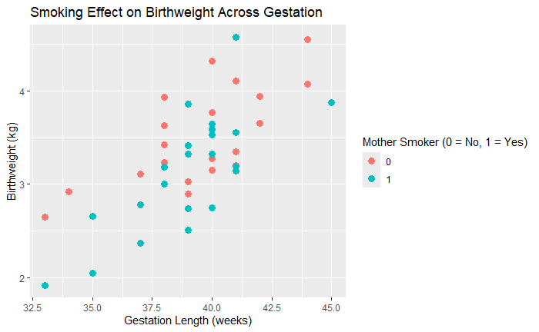
$Figure 16: Birthweight as a Function of Gestation Length by Maternal Smoking Status$

To examine whether the impact of smoking on birth weight varies across different levels of gestation, we refer to the scatterplot of birth weight versus gestation length, color-coded by maternal smoking status.

At shorter gestations between 32 and 38 weeks, the separation between smoking and non smoking mothers is most pronounced. Non smoking mothers at these gestation lengths tend to produce heavier babies than smoking mothers at equivalent gestation lengths, and the lowest birth weight babies in the entire dataset are almost exclusively from smoking mothers at the gestational range. This suggests that the negative effect of smoking on birth weight is strongest when gestation is short.

At mid range gestations between 38 and 41 weeks, where the majority of births in the dataset occur, the two groups overlap considerably. Smoking and non smoking mothers produce babies across a similar range of birth weights in this region, indicating that the negative effect of smoking on birthweight diminishes as gestation approaches full term.

At longer gestations beyond 42 weeks. The two groups converged further, with some smoking mothers producing babies of comparable birth weight to non smoking mothers. Overall, the evidence suggests that the negative effect of smoking on birth weight is not constant across gestation. Rather, it is most severe at shorter gestations and weakens progressively as gestation length increases, implying that longer development time may help compensate for the adverse effects of maternal smoking on fetal growth.

5. Covariance versus Correlation

The covariance matrix and the correlation matrix each have distinct advantages and disadvantages when used for statistical inference.

The primary advantage of the covariance matrix is that it preserves the original units and scale of the variables, meaning the magnitude of the covariance values reflects the actual variability in the data. For example, in this dataset, the covariance between length and mheight is 9.26, which carries real meaning in terms of centimeters. This makes the covariance matrix useful when the scale of relationships matters, such as when comparing the practical significance of different variable pairs.

However, the major disadvantage of the covariance matrix is that its values are not standardized, making direct comparisons across variable pairs difficult. A large covariance value does not necessarily indicate a strong relationship. It may simply reflect that the variables have large variances.

The correlation matrix addresses this directly by standardizing all values to a scale of 1 to 1, making comparisons across variable pairs straightforward and interpretable regardless of the original units. This is particularly useful in a dataset like this one where variables range from centimeters to kilograms to years of education.

The disadvantage of the correlation matrix is precisely what the covariance matrix preserves, it discards scale information entirely. Two relationships with very different practical magnitudes can have identical correlations, which can be misleading when the actual size of the effect matters. In summary, the correlation matrix is generally preferred for inference and comparison across variables, while the covariance matrix is more appropriate when the original scale of the data is relevant to the conclusions being drawn.

6. Eigenvalue Decomposition
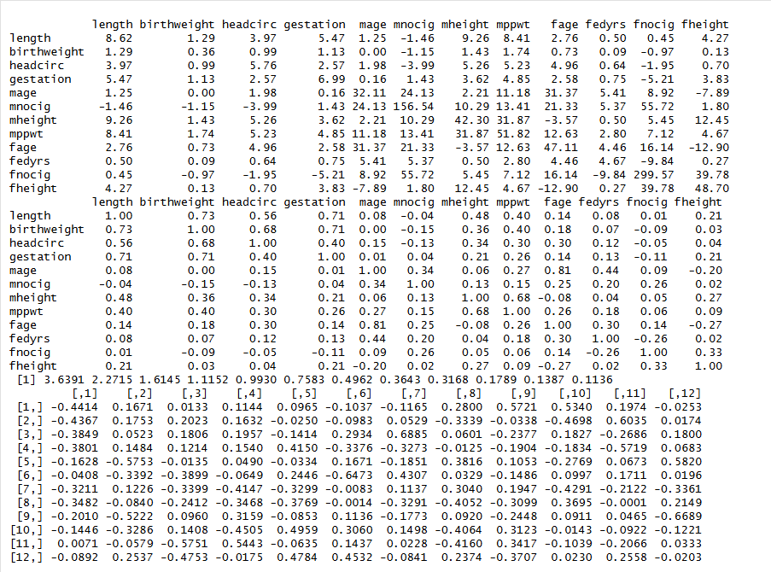
$Figure 17:$Data frame of eigenvectors
The eigenvalues of the correlation matrix of the 12 predictors are 3.64, 2.27, 1.61, 1.12, 0.99, 0.76, 0.50, 0.36, 0.32, 0.18, 0.14, and 0.11. The first three eigenvalues are notably larger than the rest, suggesting that the first three principal components capture the majority of the variance in the data. Eigenvalues greater than 1, which includes the first four, are particularly meaningful as they each explain more variance than a single standardized variable would on its own.

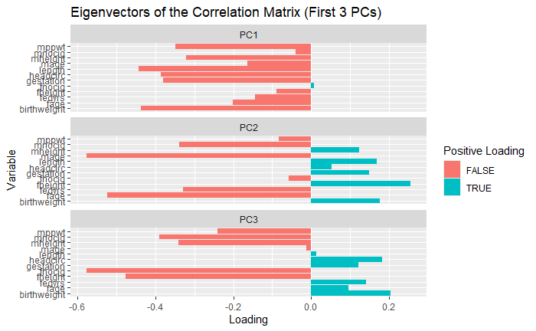
$Figure 18:Plot of the eigenvectors of the correlation matrix$

Examining the eigenvector plot for PC1, nearly all variables load negatively, with length, birthweight, headcirc, and gestation showing the strongest negative loadings around -0.44 to -0.38. This suggests PC1 represents an overall size and development axis, functioning as a general growth factor that captures the shared variation across all physical and demographic measurements.
PC2 shows a clear contrast between two groups. Maternal and paternal age variables (mage, fage) load strongly negatively, while physical baby measurements (length, birthweight) load positively. This suggests PC2 captures a parental age versus baby size contrast.
PC3 shows the strongest contrast between fnocig and gestation, with fnocig loading strongly negative and gestation and birthweight loading positively. This suggests PC3 captures a smoking related axis, where higher paternal smoking is associated with lower gestational and physical outcomes.

7. Heatmap of the Covariance Matrix

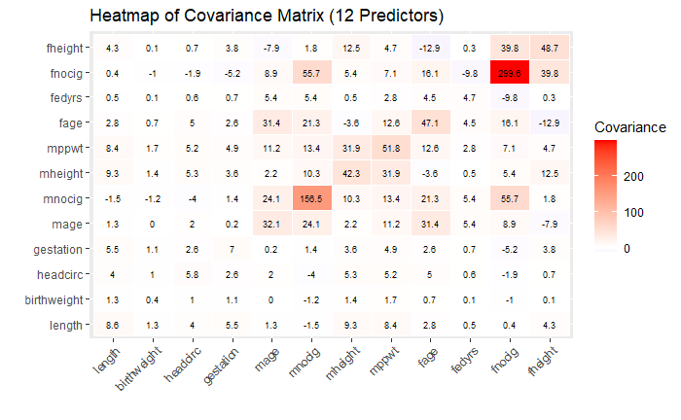
$Figure 19:Heatmap of Covariance Matrix$

The heatmap of the covariance matrix for the 12 predictors reveals several important patterns.

The most immediately striking feature is that fnocig completely dominates the color scale, with a variance of 299.6 on the diagonal, which is by far the largest value in the entire matrix. The covariance between fnocig and mnocig (55.7) is also notably large, indicating that paternal and maternal smoking habits are strongly positively related. This dominance of the smoking variables distorts the visual scale, making it difficult to discern differences among the other variables, which is precisely the limitation of the covariance matrix discussed in Q5.
The physical baby variables, specifically length, birthweight, headcirc, and gestation, all appear nearly white in the heatmap, indicating relatively small covariances compared to the smoking variables. This is not because the relationships are weak, but because their variances are small in comparison.
Maternal and paternal height variables show moderate positive covariances with the baby physical variables, consistent with the findings from Q2. The covariance between mage and fage (31.4) is also visible as a moderately red cell, confirming the strong relationship between parental ages. Overall, the heatmap demonstrates a key weakness of the covariance matrix, as variables with large variances visually overwhelm everything else, making standardization through the correlation matrix essential for fair comparison.

8. The Variable Relationship
Examining the off diagonal elements of the covariance matrix relating to mnocig, the covariances with the baby's physical metrics are as follows: mnocig and length is -1.46, mnocig and birthweight is -1.15, and mnocig and headcirc is -3.99.
All three values are negative, indicating a negative linear relationship between maternal cigarette consumption and each of the baby's physical measurements. This mother's daily cigarette consumption increases, baby length, birth weight, and head circumference all tend to decrease. This is consistent with the well documented harmful effects of maternal smoking on fetal development.
Regarding the magnitude of these values, they are relatively small compared to other covariances in the matrix, such as the fnocig variance of 299.6. However, this does not mean the relationships are weak in practical terms, as the small magnitudes are partly a consequence of the different scales of the variables. The head circumference covariance of -3.99 is the largest in magnitude among the three, suggesting that maternal smoking may have the most pronounced negative association with head circumference compared to length and birthweight. Overall, the negative signs consistently point to maternal cigarette consumption as a harmful factor across all three physical dimensions of newborn development.
9. Conclusion
This dataset provides a multidimensional view of newborn development and the factors that influence it. Across all analyses, several consistent themes emerged.
First, gestation length is the single strongest predictor of a baby's physical outcomes. Longer gestation is consistently associated with higher birthweight, greater length, and larger head circumference. Babies with the shortest gestations in this dataset were almost universally the smallest across all physical dimensions and were disproportionately classified as low birthweight.
Second, maternal smoking has a clear and consistent negative association with newborn physical development. Smoking mothers had babies with lower birthweights, and the negative effect was most pronounced at shorter gestations. The covariance analysis confirmed that maternal cigarette consumption is negatively associated with all three physical metrics. Importantly, the effect of smoking appears to interact with gestation length rather than being constant, with the gap between smokers and non smokers narrowing as gestation increases.
Third, among parental demographic factors, maternal height emerged as the most influential predictor of baby physical size, particularly baby length. Parental education level showed the weakest associations with physical outcomes across all analyses.
Fourth, the eigenvalue decomposition revealed that much of the variance in this dataset can be summarized by a small number of components, with the first four eigenvalues exceeding 1. This suggests meaningful underlying structure driven primarily by a general growth factor, a parental age contrast, and a smoking related axis.
Finally, this dataset illustrates the practical limitations of the covariance matrix for interpretation, as variables like paternal cigarette consumption with large variances visually and numerically dominate the covariance structure, making standardization through the correlation matrix essential for fair comparison across variables.

APPENDIX

library(ggplot2)
library(dplyr)
library(tidyr)
library(corrplot)
library(ggcorrplot)
birth <- read.csv("Birthweight_reduced_kg_R.csv")
head(birth)
str(birth)
summary(birth)
# lowercase everything
colnames(birth) <- tolower(colnames(birth))

# replace dots with underscores
colnames(birth) <- gsub("\\.", "_", colnames(birth))

# remove spaces
colnames(birth) <- trimws(colnames(birth))

colnames(birth)

birth <- birth %>%
mutate(
smoker = factor(smoker),
lowbwt = factor(lowbwt),
mage35 = factor(mage35)
)

colSums(is.na(birth))
summary(birth)
# Birthweight histogram
ggplot(birth, aes(x = birthweight)) +
geom_histogram(bins = 15, fill = "lightblue", color = "black") +
labs(
title = "Distribution of Birthweight",
x = "Birthweight (kg)",
y = "Count"
)
# Length histogram
ggplot(birth, aes(x = length)) +
geom_histogram(bins = 15, fill = "lightgreen", color = "black") +
labs(
title = "Distribution of Baby Length",
x = "Length (cm)",
y = "Count"
)
# Head circumference histogram
ggplot(birth, aes(x = headcirc)) +
geom_histogram(bins = 15, fill = "orange", color = "black") +
labs(
title = "Distribution of Head Circumference",
x = "Head Circumference (cm)",
y = "Count"
)
# Birthweight by smoking status
ggplot(birth, aes(x = smoker, y = birthweight)) +
geom_boxplot(fill = "lightblue") +
labs(
title = "Birthweight by Maternal Smoking Status",
x = "Mother Smoker: 0 = No, 1 = Yes",
y = "Birthweight (kg)"
)
# Birthweight vs gestation, colored by smoking
ggplot(birth, aes(x = gestation, y = birthweight, color = as.factor(smoker))) +
geom_point(size = 3) +
labs(
title = "Birthweight vs Gestation by Smoking Status",
x = "Gestation Length (weeks)",
y = "Birthweight (kg)",
color = "Smoker (0 = No, 1 = Yes)"
)
ggplot(birth, aes(x = gestation)) +
geom_histogram(bins = 15, fill = "purple", color = "black") +
labs(
title = "Distribution of Gestation Length",
x = "Gestation (weeks)",
y = "Count"
)
library(GGally)
ggpairs(birth, columns = c("birthweight", "length", "headcirc", "gestation"),
aes(color = as.factor(smoker), alpha = 0.6),
upper = list(continuous = "cor"),
lower = list(continuous = "points"),
diag = list(continuous = "densityDiag")) +
labs(title = "Pairs Plot of Key Baby Variables by Smoking Status")
# Lowest birthweight babies
birth %>%
arrange(birthweight) %>%
select(id, birthweight, length, headcirc, gestation, smoker, lowbwt) %>%
head(5)
# Highest birthweight babies
birth %>%
arrange(desc(birthweight)) %>%
select(id, birthweight, length, headcirc, gestation, smoker, lowbwt) %>%
head(5)
# Shortest gestation babies
birth %>%
arrange(gestation) %>%
select(id, birthweight, length, headcirc, gestation, smoker, lowbwt) %>%
head(5)
colnames(birth)
physical_demo <- birth %>%
select(
length,
headcirc,
birthweight,
mage,
mheight,
fage,
fedyrs,
fheight
)
# Covariance matrix
cov_physical_demo <- cov(physical_demo, use = "complete.obs")
round(cov_physical_demo, 2)
# Cross-covariance submatrix
cov_physical_parent <- cov_physical_demo[
c("length", "headcirc", "birthweight"),
c("mage", "mheight", "fage", "fedyrs", "fheight")
]

round(cov_physical_parent, 4)
# Correlation matrix
cor_physical_demo <- cor(physical_demo, use = "complete.obs")
round(cor_physical_demo, 4)
library(reshape2)

cov_melt <- melt(cov_physical_parent)
colnames(cov_melt) <- c("Physical", "Demographic", "Covariance")

ggplot(cov_melt, aes(x = Demographic, y = Physical, fill = Covariance)) +
geom_tile(color = "white") +
geom_text(aes(label = round(Covariance, 2)), size = 4) +
scale_fill_gradient2(low = "blue", mid = "white", high = "red", midpoint = 0) +
labs(
title = "Cross-Covariance: Physical Profile vs Parent Demographics",
x = "Parent Demographic Variables",
y = "Baby Physical Variables"
)
# Only covariance between baby physical variables and parent demographic variables
cov_physical_parent <- cov_physical_demo[
c("length", "headcirc", "birthweight"),
c("mage", "mheight", "fage", "fedyrs", "fheight")
]

round(cov_physical_parent, 4)
# Gestation by low birthweight status
ggplot(birth, aes(x = lowbwt, y = gestation)) +
geom_boxplot(fill = "orange") +
labs(
title = "Gestation Length by Low Birthweight Status",
x = "Low Birthweight: 0 = No, 1 = Yes",
y = "Gestation Length (weeks)"
)
ggplot(birth, aes(x = gestation, y = mnocig, color = as.factor(lowbwt), shape = as.factor(smoker))) +
geom_point(size = 3) +
labs(
title = "Gestation vs Maternal Smoking by Low Birthweight Status",
x = "Gestation Length (weeks)",
y = "Maternal Cigarettes Per Day",
color = "Low Birthweight (0 = No, 1 = Yes)",
shape = "Smoker (0 = No, 1 = Yes)"
)
# Smoking status table
table(birth$smoker, birth$lowbwt)
# Proportions by smoking group
prop.table(table(birth$smoker, birth$lowbwt), margin = 1)
# Mother cigarettes by low birthweight
ggplot(birth, aes(x = lowbwt, y = mnocig)) +
geom_boxplot(fill = "pink") +
labs(
title = "Maternal Cigarette Use by Low Birthweight Status",
x = "Low Birthweight: 0 = No, 1 = Yes",
y = "Mother Cigarettes Per Day"
)
# Father cigarettes by low birthweight
ggplot(birth, aes(x = gestation, y = fnocig, color = as.factor(lowbwt))) +
geom_point(size = 3) +
labs(
title = "Gestation vs Paternal Smoking by Low Birthweight Status",
x = "Gestation Length (weeks)",
y = "Paternal Cigarettes Per Day",
color = "Low Birthweight (0 = No, 1 = Yes)"
)
ggplot(birth, aes(x = gestation, y = birthweight, color = as.factor(smoker))) +
geom_point(size = 3) +
labs(
title = "Smoking Effect on Birthweight Across Gestation",
x = "Gestation Length (weeks)",
y = "Birthweight (kg)",
color = "Mother Smoker (0 = No, 1 = Yes)"
)
# Select 12 non-binary predictors
predictors12 <- birth %>%
select(length, birthweight, headcirc, gestation, mage, mnocig,
mheight, mppwt, fage, fedyrs, fnocig, fheight)

# Covariance matrix of the 12 predictors
cov_12 <- cov(predictors12, use = "complete.obs")
round(cov_12, 2)

# Correlation matrix
cor_12 <- cor(predictors12, use = "complete.obs")
round(cor_12, 2)

# Eigenvalues and eigenvectors of the correlation matrix
eigen_12 <- eigen(cor_12)
eigenvalues <- eigen_12$values
eigenvectors <- eigen_12$vectors

round(eigenvalues, 4)
round(eigenvectors, 4)
# Create a dataframe of the first 3 eigenvectors
eigenvector_df <- data.frame(
Variable = colnames(cor_12),
PC1 = eigenvectors[, 1],
PC2 = eigenvectors[, 2],
PC3 = eigenvectors[, 3]
)

# Melt for plotting
eigen_melt <- melt(eigenvector_df, id.vars = "Variable",
variable.name = "Component", value.name = "Loading")

ggplot(eigen_melt, aes(x = Variable, y = Loading, fill = Loading > 0)) +
geom_bar(stat = "identity") +
facet_wrap(~Component, ncol = 1) +
coord_flip() +
labs(
title = "Eigenvectors of the Correlation Matrix (First 3 PCs)",
x = "Variable",
y = "Loading",
fill = "Positive Loading"
)
cov_melt12 <- melt(cov_12)
colnames(cov_melt12) <- c("Var1", "Var2", "Covariance")

ggplot(cov_melt12, aes(x = Var1, y = Var2, fill = Covariance)) +
geom_tile(color = "white") +
geom_text(aes(label = round(Covariance, 1)), size = 2.5) +
scale_fill_gradient2(low = "blue", mid = "white", high = "red", midpoint = 0) +
theme(axis.text.x = element_text(angle = 45, hjust = 1)) +
labs(
title = "Heatmap of Covariance Matrix (12 Predictors)",
x = "",
y = ""
)

